Ideation Phase
Brainstorm & Idea Prioritization Template

Date | 29 September2026
Team ID | 6ab3d326a238dc999eb36ed1
Project Name | AI Weather Wise API
Maximum Marks | 4 Marks

Brainstorm & Idea Prioritization – AI WeatherWise API
Brainstorming provides a free and collaborative environment where team members can share ideas, identify problems, and develop creative solutions. For the AI WeatherWise API project, the brainstorming process focused on improving the way users access weather information, manage favorite locations, and receive personalized weather recommendations using Artificial Intelligence.

Step-1: Team Gathering, Collaboration and Select the Problem Statement
The team discussed the common difficulties faced by users while checking and understanding weather information.

Problem Statement
Users often need to check weather conditions for different locations, but raw weather data may be difficult to understand. They may also need personalized suggestions such as suitable outdoor activities, clothing recommendations, and simple weather summaries.

Identified Problems
- Difficulty in tracking weather conditions for multiple locations.
- Difficulty understanding raw weather data and metrics.
- Lack of personalized weather recommendations.
- Need for natural-language weather summaries.
- Difficulty managing favorite locations efficiently.
- Need for secure user authentication and preference management.

Proposed Solution
Develop AI WeatherWise API, a RESTfull Backend system that provides real-time weather information and uses Google Gemini AI to generate intelligent weather summaries and personalized recommendations.

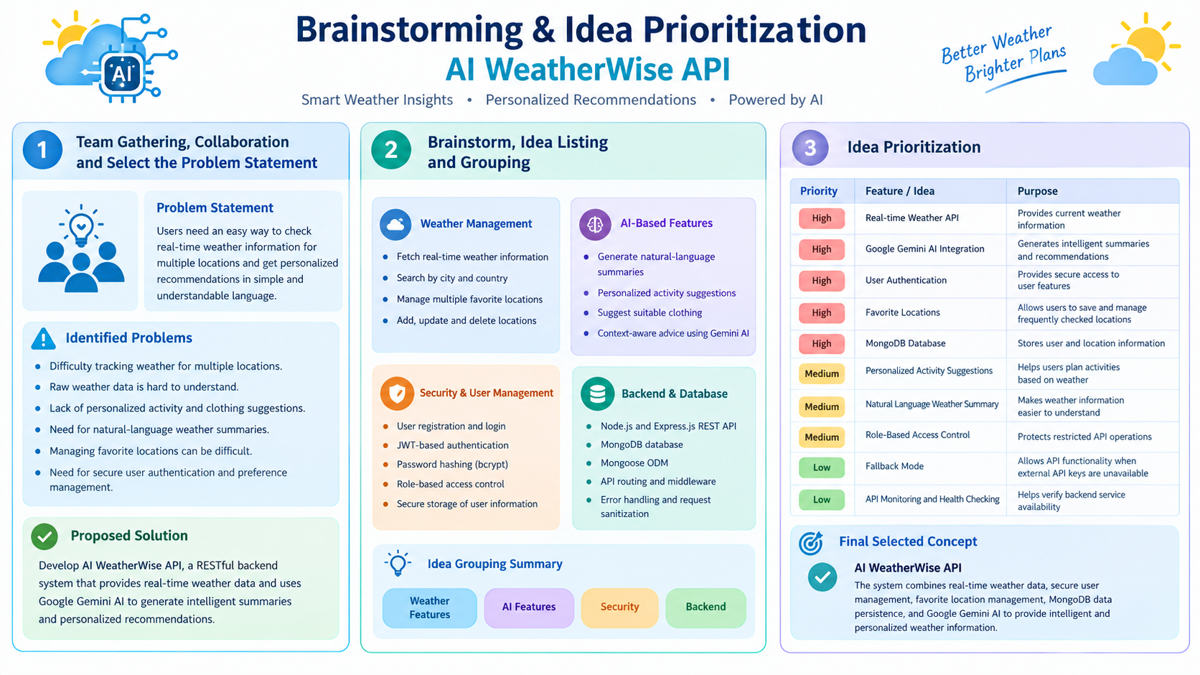

Step-2: Brainstorm, Idea Listing and Grouping
The team generated and grouped ideas based on the major requirements of the AI WeatherWise project.

Weather Management
- Fetch real-time weather information.
- Search weather by city and country.
- Manage multiple favorite locations.
- Add, update, and delete favorite locations.

AI-Based Features
- Generate natural-language weather summaries.
- Provide personalized activity recommendations.
- Suggest suitable clothing based on weather conditions.
- Provide context-aware weather advice using Gemini AI.

Security and User Management
- User registration and login.
- JWT-based authentication.
- Password hashing using bcrypt.
- Role-based access control.
- Secure storage of user information.

Backend and Database
Node. js and Express.js REST API.
MongoDB database.
Mongoose ODM for database operations.
API routing and middleware.
Centralized error handling and request sanitization.

Step-3: Idea Prioritization
After brainstorming and grouping the ideas, the team prioritized them according to their importance to the AI WeatherWise system.
Priority | Idea / Feature | Purpose
High | Real-time Weather API | Provides current weather information
High | Google Gemini AI Integration | Generates intelligent summaries and recommendations
High | User Authentication | Provides secure access to user features
High | Favorite Locations | Allows users to save and manage frequently checked locations
High | MongoDB Database | Stores user and location information
Medium | Personalized Activity Suggestions | Helps users plan activities based on weather
Medium | Natural Language Weather Summary | Makes weather information easier to understand
Medium | Role-Based Access Control | Protects restricted API operations
Low | Fallback Mode | Allows API functionality when external API keys are unavailable
Low | API Monitoring and Health Checking | Helps verify backend service availability

Final Selected Concept
AI WeatherWise API was selected as the project concept. The system combines real-time weather data, secure user management, favorite location management, MongoDB data persistence, and Google Gemini AI to provide intelligent and personalized weather information.

